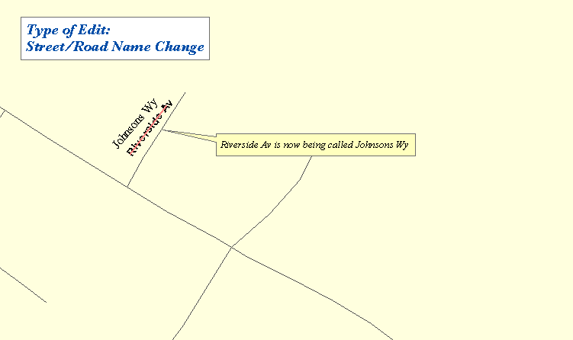

One Maine Enhanced 9-1-1 Update Form will need to be filled out for the above edit. The following sections are found on MSAG Update Forms and serves as an example as to what information needs to be provided to Emergency Services Communications Bureau/GIS in order to complete the edit. In addition, please provide all the information noted on the map above by marking it on a copy of the map book page. Please submit both the map book page and the Update Form to Emergency Services Communications Bureau/GIS.

FORM 1

- □ C. Steet Name Change | Effective Date: 1/24/2003
1. Old Street Name: Riverside Av
2. New Street Name: Johnsons Wy

Remarks: Town changed road name to eliminate similar sounding/duplicate road name within the town.

